Kingdom of Saudi Arabia
Ministry of Education

Course name: Computer Security
Project Title: Playfair Cipher Programming

Table of Contents

Introduction: 4
System Description: 4
Playfair cipher Logic: 4
Graphical user interface: 4
Algorithm Description: 5
Prepare the text: 5
Create the key matrix: 5
Encryption rules : 5
Decryption rules : 5
Gui interface : 5
System testing: 6
Conclusion : 8
Refences lists : 8

Project Marking Guide (Programming Project)

 | Assignment Component | Max. Marks
 |  |  | Marks Obtained
REPORT | Format (Table of Contents, References, formatting and font, etc....) | 10
 | English language (grammar and spelling) | 10
 | Introduction | 15
 | References | 10
 | Contents  Algorithms, and Discussions / Coding | 30
Demonstration | Questions and answers | 15
 | Interface Design & Usability | 15
 | Testing (Various Input Conditions) | 15
 | Presentation skills | 15
 | Understanding / Explanation of the code | 15
 | Total Marks | 150
 | Grade for this Project | 15
 | Plagiarism reports more than 10% to 25%  Plagiarism reports more than 25% to 40%  Plagiarism report more than 40% | - 5  -10  -20

Introduction:

Encryption is one of the most important means of computer security in the current era, as it provides security, confidentiality, and protection of information from unauthorized access so that it converts text into incomprehensible text and encryption keys to convert data into an unreadable format, depending on computer techniques or mathematical equations, as well as in protecting sensitive communications. The main subject of our focus today will be the Playfire encryption system and its operational aspects together with its advantageous features.

System Description:

This system was built as a local Saudi tool for encrypting and decrypting Playfair. The system will be a standalone application for Windows and Mac devices, with official access limited to professional use. It was built using Python to implement two main components:

The front-end of the program: Specialized in writing text and keywords for encryption and decryption and displaying the final output specifically in the user interface.

The back end of the program: Specialized in the internal implementation, which captures user input and converts it into variables that are encrypted and decrypted using Playfair algorithms.

Algorithm Description:

Prepare the text:

- Making all letters uppercase.
- Replace ‘J ‘with ‘I ‘.
- If there are two of the same letters next to each other, add an ‘X’ between them.
- If the text has an odd number of letters, add an ‘X ‘at the end.

Create the key matrix:

  - Take the keyword and remove any repeated letters.
  - Add the remaining letters of the alphabet without ‘J’
  - Arrange everything into a 5x5 grid.

Encryption rules:

For each pair of letters:
- If they are in the same row, take the letter to the right [1].
- If they are in the same column, take the letter below [1].
- If they make a rectangle, swap the columns between them [1].

Decryption rules:

For each pair of letters:
- If they are in the same row, take the letter to the left [1].
- If they are in the same column, take the letter above [1].
- If they make rectangle, swap the columns like in encryption [1].

Gui interface:
    - A place to type next to encrypt or decrypt.
    - A place to type the keyword.
    - Buttons to choose between encrypt and decrypt.
    - A “Proceed” button to show the result.
    - A box to show the output.
    - A background image to make the app look better.

System Requirements:

Python:
You must have Python installed on your machine. Python 3.7 or later is preferred.
Make sure you have added Python to the PATH environment variable upon installation.

Required Libraries:
You need to install the libraries to run the program: Customtkinter – Pillow – tkinter
To install these libraries, you can use pip to install it. Copy this command into the terminal:
pip install customtkinter pillow tkinter

Setting up the environment in VS Code:
Make sure you have installed the Python Extension in VS Code.

Background Image Path:
Make sure the background image you specified in the code is in the correct path.
bg_path = r"COPY THE PATH OF BACKGROUND HERE"

System testing:
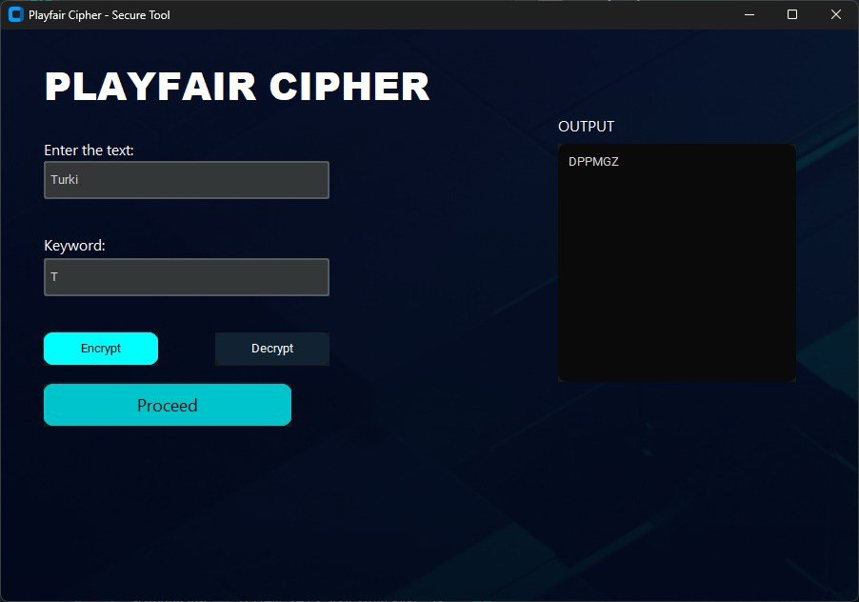
Using VS code for compiling the code :

Encrypt the text “ Turki “ with Key “ T “ the output: DPPMGZ
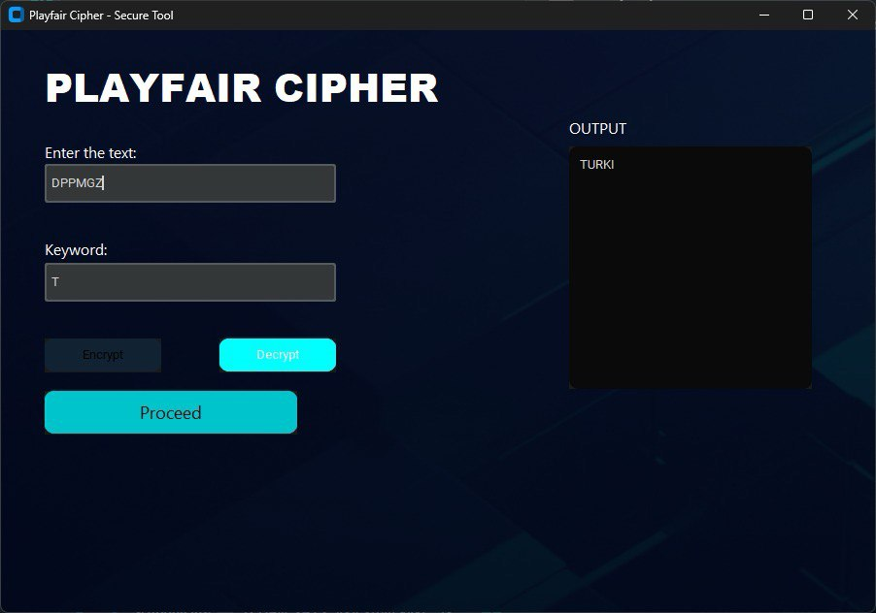

Decrypt DPPMGZ with same key to verify the process

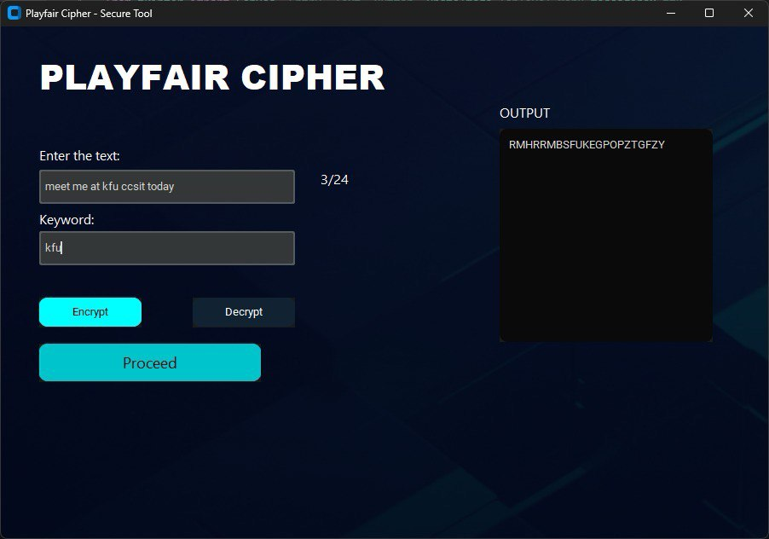
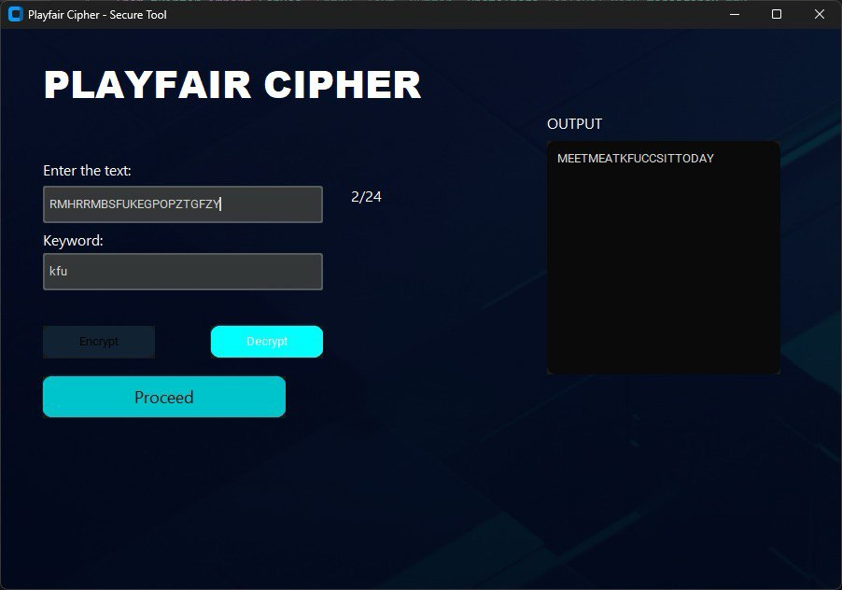

Conclusion:

In this project the program used Playfair cipher for automatic encryption and decryption of messages. The program follows the correct rules of cipher. Users can easily operate our system because it comes with an interactive interface. The system demonstrates complete precision by executing the Playfair rules in all circumstances.

Refences lists:

[1] | https://www.tutorialspoint.com/cryptography/cryptography_playfair_cipher.htm

